**VMWare (Centos7) Installation :**

Download Vm-ware workstation player for 64/32 bit from the below link

VMware Workstation 12.5.2 Player, Download and Install

<https://www.vmware.com/go/tryplayerpro-win-64>

or

<https://my.vmware.com/en/web/vmware/free#desktop_end_user_computing/vmware_workstation_player/12_0>

**Alterante 32 bit link :**

<http://filehippo.com/download_vmware_player/>

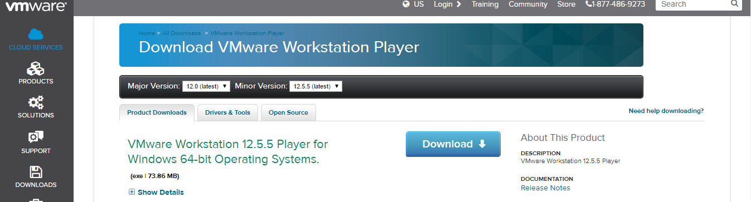

Download Linux Centos 7 -minimal ISO from the below link

**64Bit:**

<http://isoredirect.centos.org/centos/7/isos/x86_64/CentOS-7-x86_64-Minimal-1611.iso>

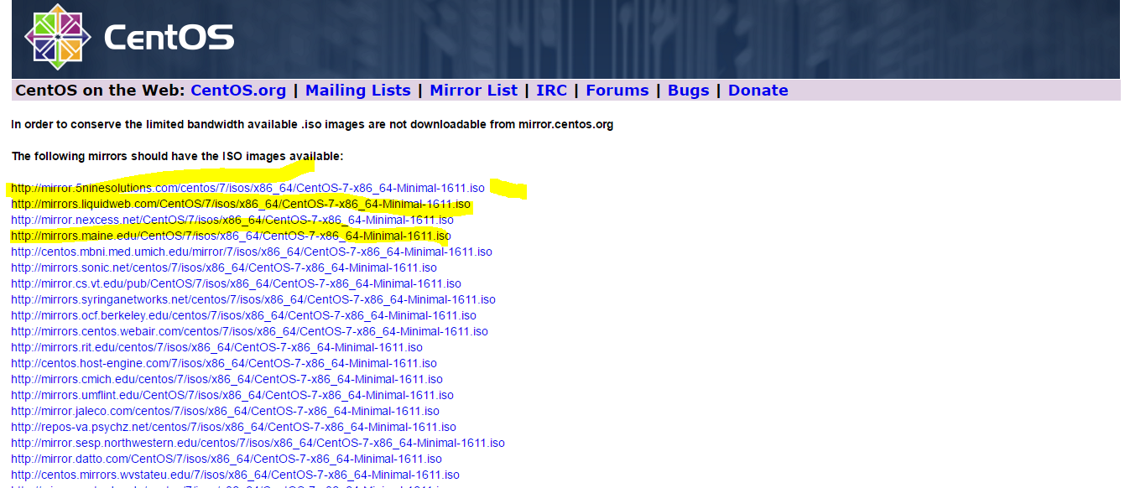

**32Bit:**

<https://lists.centos.org/pipermail/centos-announce/2015-October/021430.html>

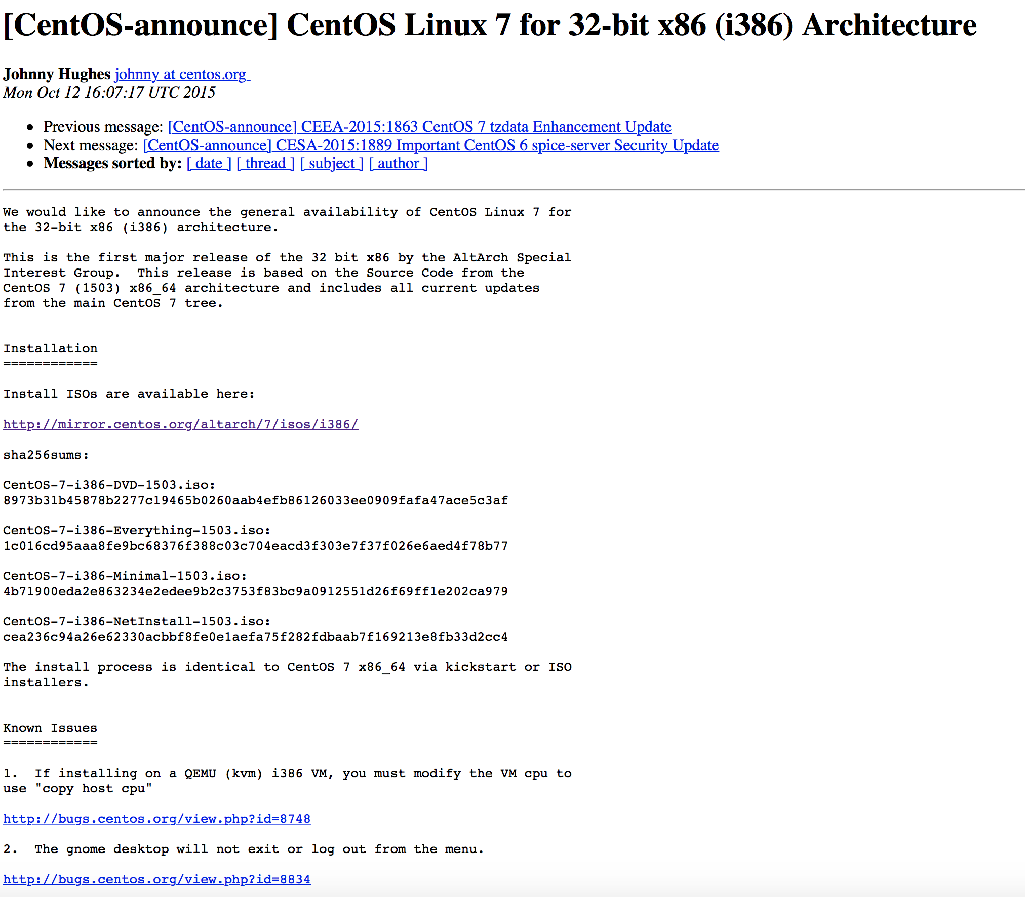

Installing Centos :

1. Selelct the  new virtual machine and name it

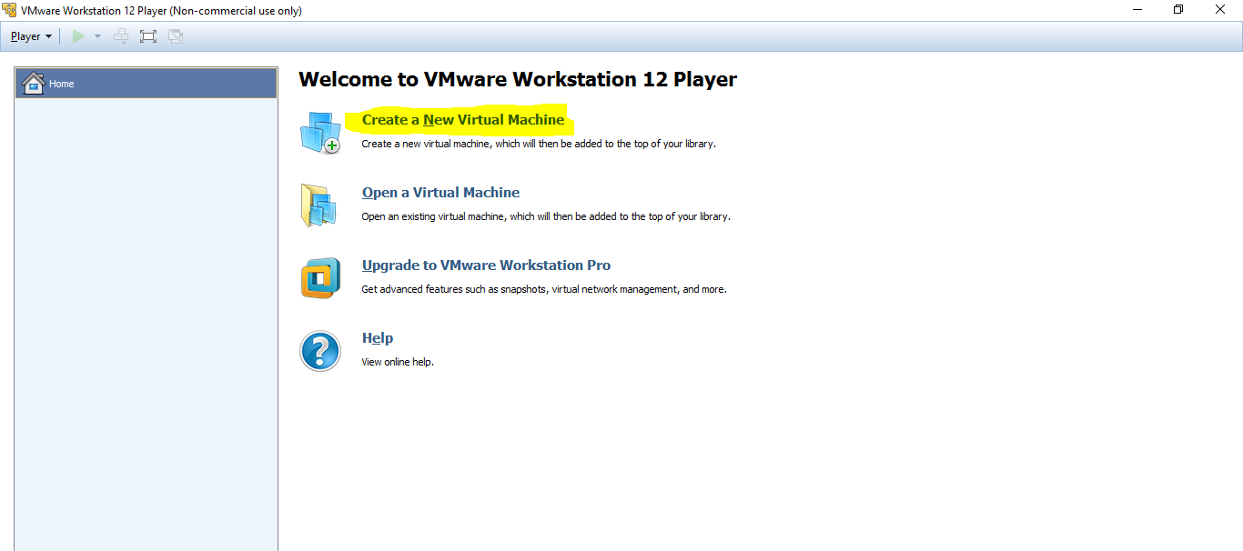

1. Select the downloaded ISO file and click next

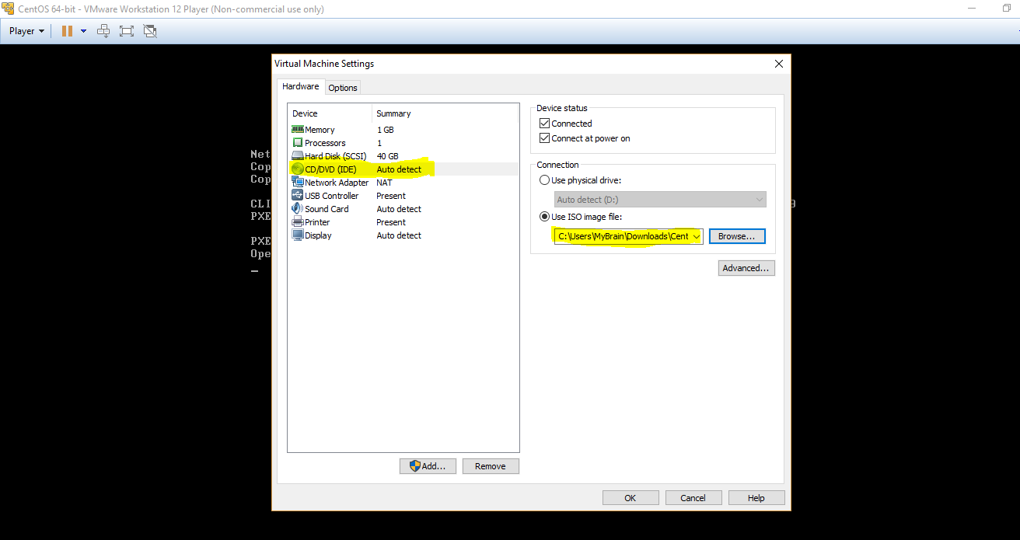

1. Selections
2. Network: Bridged
3. RAM: 1GB
4. Memeory : 40GB (Selelct option to store in single disk)
5. It will ask for settings starting choose the password and select all defaults
6. ** The network Must be connected to Bridged and it will shows the **Connected**